OPEN
media pty limited
Box 613, Brighton Le Sands
NSW 2216, Australia
Tel 02 8006 4948
E-mail simv@pobox.com

28 July 2026
Invoice # OM101017

3e Consulting
272 1ST Ave Apt 10E
NEW YORK, NY 10009-1804

SERVICE PERIOD TOTAL VALUE US$
Payment for 3e for transfer Cancun-Playa 13 Oct 2010 US$70
Paid Cash
Signature....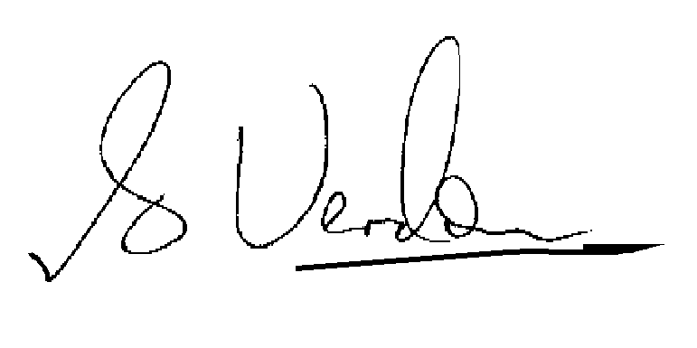
S.I.M. Verdon, Director, Open Media Pty Limited

