

Napier Capital
1592 Union street
San Francisco, CA 94123

Telephone: (510) 558-1970
FAX: (603) 452-5614

ENGAGEMENT AGREEMENT

July 31, 2026

Mr. Simon Verdon
President
Open Communications, Inc.
10640 N 28th Drive, Suite A200

Phoenix, AZ 85029-2910

Dear Simon,

We, Napier Capital Partners (NCP), propose to enter into a business agreement to provide contacts that will purchase or provide funds necessary to generate a suitable business development, sales and working capital base for Open Communications, Inc. (OCI). This agreement will commence from the date of acceptance by OCI Inc. and will continue until it is terminated, by either party, upon receipt of 30 days written notice. The minimum period this agreement will be in effect for is 30 days.

NCP will receive equity participation and fees for its advisory services, as prescribed herein;

Cash | US$600,000 | 700,000 | 800,000 | 900,000 | 1,000,000 | 1,100,000
Advisory Fee* | 8% | 8% | 9% | 9% | 10% | 10%
Equity Participation** | 8% | 8% | 9% | 9% | 10% | 10%
Total Fee | $48,000 | $56,000 | $72,000 | $81,000 | $100,000 | $110,000

*percent of all cash paid to OCI
**percent of all securites paid to OCI

This agreement will cover all fundraising or acquistion activity with parties introduced to OCI by NCP for a period of one year following termination of this agreement.

Offered by: Accepted by:

__________________________ 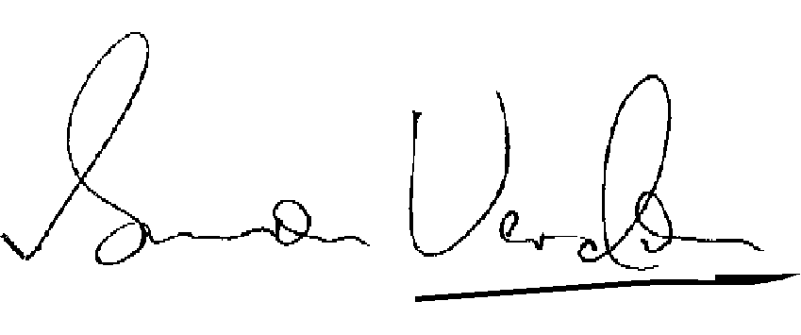
Gavin Taylor, Date: July 31, 2026 SimonVerdon, Date: July 31, 2026

Napier Capital Partners Open Communications, Inc.

