2GoInc.
272 1st Avenue, Apt 10E
New York, NY 10009
United States
Tel ~ 1-347-471-0816
E-mail ~ simv@pobox.com

31 July, 2026
Bondi to Belgrade and Looking for Bon
Dear Lindsay,
Please accept this letter as my agreement to serve as Production Comptroller on the above projects, should you decide to engage my services. Obviously, this commitment is contingent upon agreeing the fee and the extent of my involvement. In that context, I have used the term Comptroller above to indicate a responsibility for budgetary control and production reporting but not the day to day disbursement of funds. As we have discussed, I may undertake this role remotely over the internet.
Thank you,
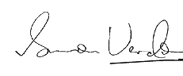
Simon Verdon

