Lavish Choice Ltd

46 Elm Grove, Barnham
PO22 0HL, England
Tel: 07954 342130
E-mail: admin@LavishChoice.co.uk
UK Company Number: 07183642

28 July 2026
Simon Ian Martin Verdon

Consular Department
Syrian Embassy
London

To Whom It May Concern:
Simon Verdon is an employee, director, and 100% owner of Lavish Choice Limited.
Lavish Choice is an internet-based seller of perfumes and cosmetics, present online at www.LavishChoice.co.uk. The company has an established banking facility with HSBC, and supplies products direct from wholesalers to end customers.
Signature....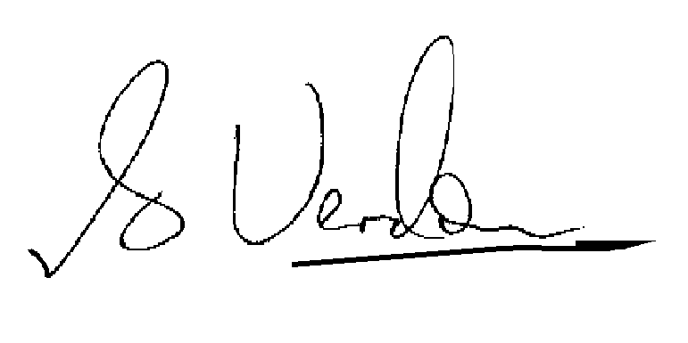
S.I.M. Verdon, Director, Lavish Choice Limited

