OPEN
media pty limited
Box 613, Brighton Le Sands
NSW 2216, Australia
Tel 02 8006 4948
E-mail simv@pobox.com

30 July 2026
Invoice # OM100905

Quality4fe Limited
46 Elm Grove
Barnham PO22 0HL

SERVICE PERIOD TOTAL VALUE £
Creation of main website pages using
Wordpress and integration of
Associates database system Sept 2010 £600.00
Payable 7 days
Signature....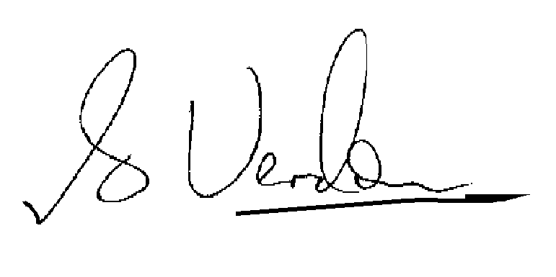
S.I.M. Verdon, Director, Open Media Pty Limited

