Box 3741, GPO Sydney
NSW 2001, Australia
Tel  02 9380 2848
E-mail  simv@pobox.com

Wednesday, November 19, 2008

Loan from Sam Barber
I acknowledge receipt of a loan of A$5,000 from Sam Barber, repayable on 14 days notice, with interest at a rate of 20% payable monthly.

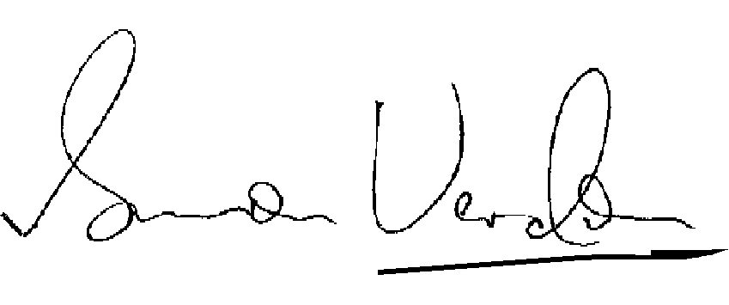
Simon Verdon

