Curriculum Vitae
2/60 William St
Sydney NSW 2010
Tel: 0405-994774
E-mail: simv@pobox.com

..........
.
.
.
.
.
..
.
.
.

Simon
Verdon

Chartered Accountant with CEO and CFO expertise
Founder and CEO of U.S./Australian e-commerce business
Founder and CEO of Australian/Asian video training business
Initial CFO (through to IPO) of division of major media conglomerate
Reporting to board, investors, and lenders
Identifying and securing product and media rights
Selection, management & training of international and Australian staff
Extensive experience in Australia, U.K., U.S.A, & Hong Kong
Seeking a challenging part-time position

Simon Verdon
Curriculum Vitae
Open Communications (USA) 1994 to present
- Wholly-owned Arizona corporation, formed in 1994 when I moved to the USA
- Established e-commerce business when the internet was in its infancy
- Gained US resident status on the strength of that business alone
- Created many systems and processes from scratch as there were no ‘off the peg’ applications available
- Convinced skeptical suppliers to allow us to sell online
- Initially some 3 million mainstream product listings
- Deep search engine presence
- Approximately 20,000 unique visitors per day
- One of few remaining sites which rely solely upon internet e-commerce (‘pure play’ websites)
- Bootstrapped and survived totally with internal finance, through astute product selection, rigorous cost control, and highly-targeted marketing
- Concentrate on hard to find books, perfumes and cosmetics, and other smaller niche product areas
- Sought out product lines capable of very precise description
- Set about having the items listed precisely on search engines without having to compete for position with generic descriptions
- Have less than ten major suppliers, most of whom ship direct to our customers, so we do not carry any stock
- Deliver worldwide but have learned how to minimize fraud to the point where this has reached almost zero
- Developed valuable contacts in site design, content, marketing, and back office operations.

Key Experience & Achievements:
15 years of e-commerce in the US and world markets
Understanding product requirements for successful e-commerce
Negotiating product distribution rights
Website design and page design to maximize exposure
Analysis of allowable promotion margin on marketing projects
Knowledge of tools to secure search engine placement
Application of cost control at product and overhead levels
Avoidance of credit card fraud
The following chart is some measure of our success. It assesses the cross links to our pages from third party sites and compares the total linking to us with others in the media sector. Based on these statistics, two of our sites are classed as a ‘Players’ and the largest as a ‘900 pound gorilla’. [Seek.com.au is included for comparison].
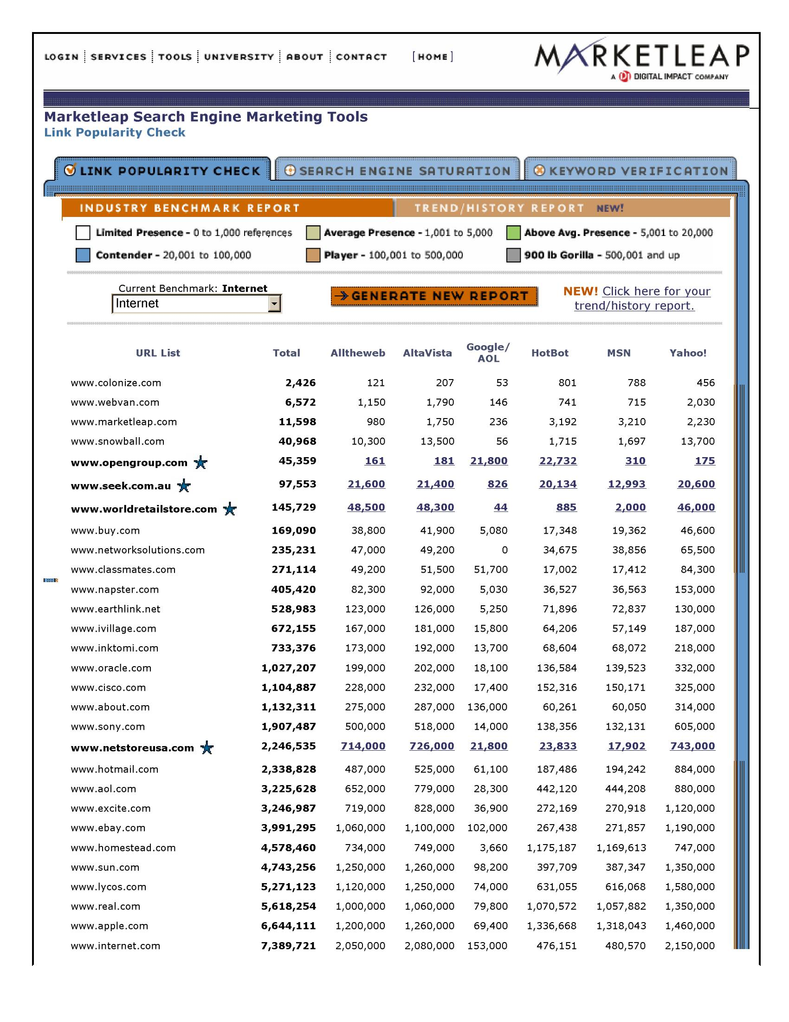

After 11 enjoyable years in the USA, I decided for personal reasons to return to Australia. The company continues to operate in my absence with minimal remote involvement.

Simon Verdon
Curriculum Vitae
.
.
.
.
.
. .
.
.
.
.
.
..
.
.
.
.
.
.
.
.
..
.
.
..
.
.

Catch 123 (Australia) 1984 to 1986
- My wholly owned Australian company formed to exploit portable computers in the context of film production
- Previously movie production accounting was a hopelessly historic affair. Films costing multi-millions would be all but finished before accurate cost analyses were available
- Introduced portable PC’s in their early years to provide timely financial information during the course of film production
- Became adept at amending computer software, using a variety of programs to meet the needs of production companies in controlling and monitoring finances.
We sold the film production accounting business to one of our staff after about 3 years.

Key Experience & Achievements:
Adapting proprietary software to produce a specialised solution
Self-taught detail of many computer programs
Awareness of the film finance and production processes
Reporting financials to creative non-accountant professionals

Open Media (Australia) 1990 to present
- Leveraged our knowledge of the film-making process involvement in training film distribution, to produce a series of Australian training videos using well-known local actors
- Also produced 3 session-starter motivational videos which I scripted
- Licensed the videos for distribution in Australia and worldwide
- Six videos we produced generated some A$1.5million in gross sales in their 14 year life
- Open Media now concentrates as the Australian arm of Open Communications for internet sales
Key Experience & Achievements:
Motivational training principles
Video production processes
Locating and licensing worldwide distributors

Simon Verdon
Curriculum Vitae
.
.
.
.
.
.
..
.
.

First Training 1985 to 1993
- Left the Packer organisation to found training video distribution company with an external investment of A$250,000
- Company was later to become First Training, the largest distributor of training videos in the Southern Hemisphere
- During this entire period I was Joint Managing Director
- Worked very closely with my founding partner who managed the sales force, and we learned how to execute and develop ideas jointly
- Started with a few distribution licenses and in the end we had all the licenses and no practical competitors
- Gaining those licenses from international distributors required tenacity and inventiveness, which was both challenging and rewarding
- We grew partly through the acquisition of licenses, but also from internal sales expansion and never allowing a marketing opportunity to pass by
- When I sold my shareholding, First Training had grown from startup to a business with A$8 million in annual sales from 9 offices in 4 countries, employing 50 staff

Key Experience & Achievements:
Being responsible for all aspects of a new business
Negotiating with shareholders and lenders
Being a CEO but developing ideas in cooperation with others
Using new technology to improve company performance
Creating a large company from zero

Simon Verdon
Curriculum Vitae
.
.
.
.
.
.
..
.
.

Publishing and Broadcasting Video 1982 to 1985
- One of Kerry Packer’s senior executives came to Melbourne to ask if I wanted to be involved in the financial control of an absolutely new technology – home video
- I was Vice President, Finance of a division of Channel 9 which had committed multi-millions to product rights when I joined without any form of structure
- Went from zero to approximately $40million a year in sales in about two years
- My job was to create a financial and organisational structure
- Liaised with the divisional Vice Presidents and the holding group to ensure they had the decision-making information and planning assistance they required
- Established operating subsidiaries in Asia with systems to manage the many and complex video licensing agreements which had been concluded with US and European movie studios
- The group engaged in many new ventures and acquisitions and in all cases, I was involved in the ‘due diligence’ process
- Became General Manager of Video Channel, a relatively small division which distributed training videos to businesses
- During this period, the entire group was the subject of an IPO and was successfully listed on the ASX. As a continuing member of the senior management, I was involved in the production of the prospectus and was awarded options in the new venture
- Over the next 18 months we grew Video Channel by 100% and I made an offer with my Sales Manager to acquire the division but failed to reach agreement with the new holding company

Key Experience & Achievements:
Meeting the needs of corporate management
Liaising with holding company executives
Managing a diverse range of staff in a large group
Assessing new business opportunities and merging with existing divisions
Doubling an existing, mature business

Simon Verdon
Curriculum Vitae
.
.
.
.
.
.
..
.
.

Binder Hamlyn, Australia 1980 to 1982
- Undertook special financial projects for the Packer group including ski resort profitability analysis and special interest magazine publishing
- Offered position as partner-elect of the Melbourne office at age 30
Peat Marwick, Hong Kong 1980
- Conducted special investigations and acquisition due diligence for a number of the largest corporations in Hong Kong – PM was one of the two audit giants in Hong Kong at that time
- Audit manager for the firms biggest audit client - Hong Kong Electric
Binder Hamlyn, London 1972 to 1979
- qualified as a Chartered Accountant with this London firm which was at the time one of the ten largest firms in England
- Responsible for the largest audit clients which brought me into social contact and negotiation with directors of public companies

Key Experience & Achievements:
Communicating effectively at senior management level
Managing a large staff in disparate, simultaneous projects
Extensive media industry experience (film; publishing; billboard advertising)
.
.
.
.
.
.
..
.
.

Simon Verdon
Curriculum Vitae
.
.
.
.
.
.
..
.
.

Personal Information
Date of birth |  | 16th August 1951
Place of birth |  | London
Nationalities |  | Australian & British
Health |  | Good
Marital Status |  | Divorced; no children
Education
University of Kent, Canterbury | BA with Honours in Accounting |  | 1969 to1972
Merchant Taylors’ School | 8 Ordinary Levels; 3 A Levels |  | 1962 to 1969
Qualifications
Fellow of the Institute of Chartered Accountants in England & Wales |  |  | 1975
Employment
Open Communications Inc | Owner and President |  | 1994 to present
First Training Pty Limited | Joint Managing Director |  | 1986 to 1993  Salary: A$35,000->A$110,000
Open Media Pty Limited | Owner; Producer; Distributor |  | 1985 to present
Video Channel Pty Limited and  Publishing & Broadcasting Video | General Manager  Vice President - Finance |  | 1984 to 1985  1982 to 1984  Salary: A$30,000->A$75,000
Catch 123 Pty Limited | Owner |  | 1983 to 1985
Binder Hamlyn, Australia | Manager; Partner designate |  | 1981 to 1982
Peat Marwick, Hong Kong | Audit Manager |  | 1980
Binder Hamlyn, London | To Audit Manager |  | 1972 to 1979
Companies above owned by Verdon are italicised.

